Exp 1
8-Puzzle Problem
from collections import deque

from collections import deque

def get_neighbors(state):
neighbors = []

zero = state.index(0)
row, col = divmod(zero, 3)

moves = [
(-1, 0), # Up
(1, 0), # Down
(0, -1), # Left
(0, 1) # Right
]

for dr, dc in moves:
new_row = row + dr
new_col = col + dc

if 0 <= new_row < 3 and 0 <= new_col < 3:
new_state = list(state)

new_zero = new_row * 3 + new_col

new_state[zero], new_state[new_zero] = \
new_state[new_zero], new_state[zero]

neighbors.append(tuple(new_state))

return neighbors

def solve(start, goal):
queue = deque()
queue.append((start, [start]))

visited = {start}

while queue:
state, path = queue.popleft()

if state == goal:
return path

for next_state in get_neighbors(state):

if next_state not in visited:
visited.add(next_state)

queue.append(
(next_state, path + [next_state])
)

return None

def print_state(state):
for i in range(0, 9, 3):
print(state[i:i+3])
print()

# Initial state
start = (
1, 2, 3,
4, 0, 6,
7, 5, 8
)

# Goal state
goal = (
1, 2, 3,
4, 5, 6,
7, 8, 0
)

# Solve the puzzle
solution = solve(start, goal)

if solution:
print("Solution Steps:")
print()

for step, state in enumerate(solution):
print("Step", step)
print_state(state)

else:
print("No solution exists.")

Output:

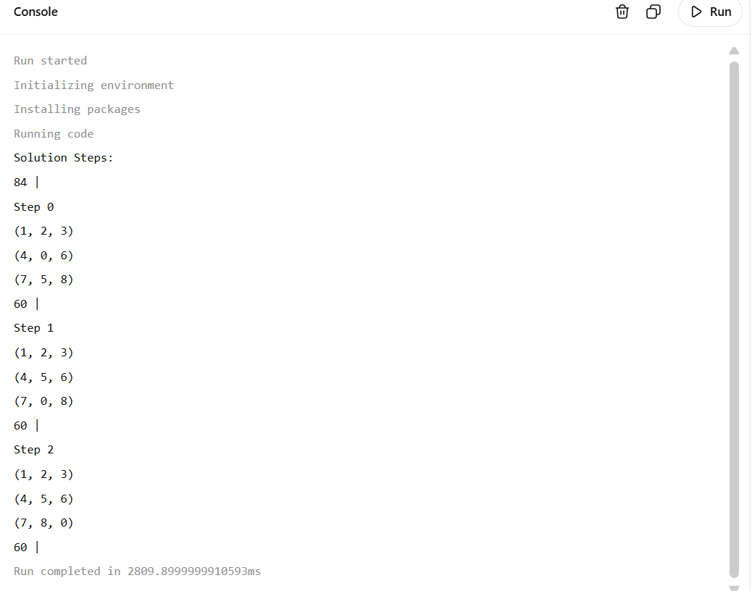

Exp 2

8-Queen Problem

def is_safe(board, row, col):
for i in range(row):
if board[i] == col:
return False

if abs(board[i] - col) == abs(i - row):
return False

return True

def solve(board, row):
if row == 8:
return True

for col in range(8):
if is_safe(board, row, col):
board[row] = col

if solve(board, row + 1):
return True

board[row] = -1

return False

board = [-1] * 8

print("Solution for 8-Queen Problem:")

if solve(board, 0):

for row in range(8):

line = ""

for col in range(8):

if board[row] == col:
line = line + "Q "
else:
line = line + ". "

print(line)

else:
print("No solution")

Output:
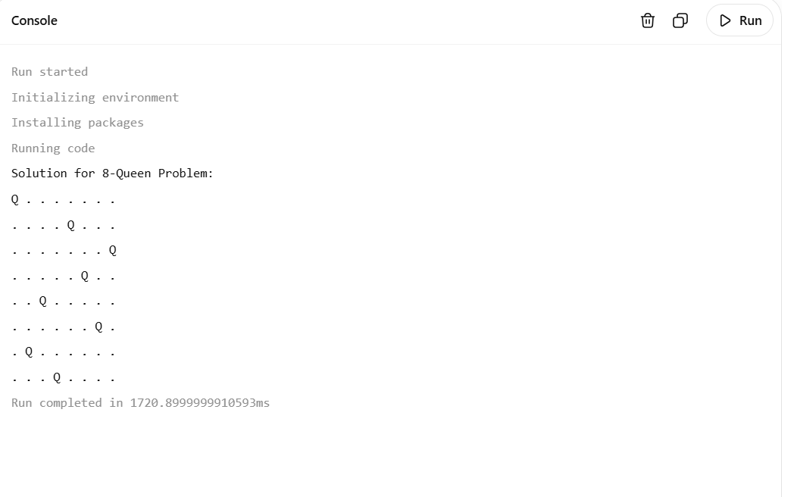

Exp 3
Water Jug Problem

from collections import deque

def water_jug(capacity1, capacity2, target):
queue = deque()
queue.append((0, 0))

visited = set()
visited.add((0, 0))

parent = {}
action = {}

while queue:

a, b = queue.popleft()

if a == target or b == target:

path = []
state = (a, b)

while state != (0, 0):
path.append((state, action[state]))
state = parent[state]

path.append(((0, 0), "Start"))
path.reverse()

return path

states = []

# Fill Jug 1
states.append(((capacity1, b), "Fill Jug 1"))

# Fill Jug 2
states.append(((a, capacity2), "Fill Jug 2"))

# Empty Jug 1
states.append(((0, b), "Empty Jug 1"))

# Empty Jug 2
states.append(((a, 0), "Empty Jug 2"))

# Pour Jug 1 into Jug 2
amount = min(a, capacity2 - b)
states.append((
(a - amount, b + amount),
"Pour Jug 1 into Jug 2"
))

# Pour Jug 2 into Jug 1
amount = min(b, capacity1 - a)
states.append((
(a + amount, b - amount),
"Pour Jug 2 into Jug 1"
))

for next_state, move in states:

if next_state not in visited:

visited.add(next_state)
parent[next_state] = (a, b)
action[next_state] = move

queue.append(next_state)

return None

# Jug capacities
jug1 = 4
jug2 = 3

# Required amount
target = 2

solution = water_jug(jug1, jug2, target)

if solution:

print("Water Jug Problem Solution:")
print()

for state, move in solution:
print(move)
print("Jug 1 =", state[0])
print("Jug 2 =", state[1])
print()

else:
print("No solution exists.")

Output:
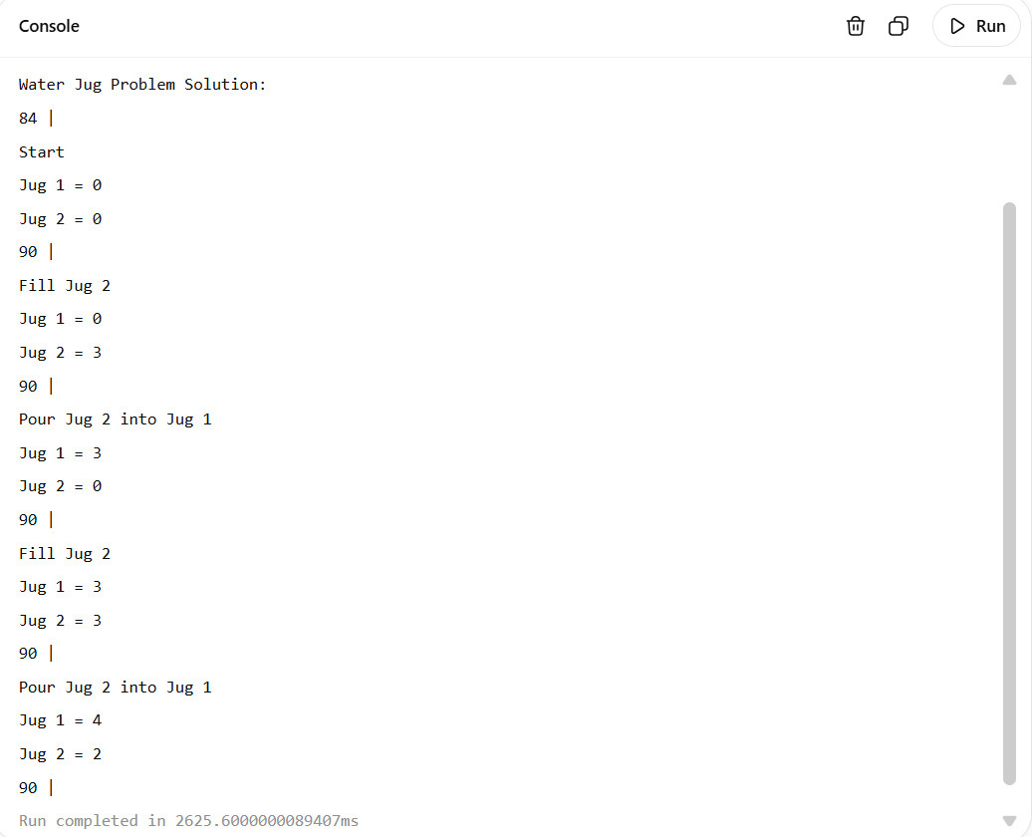

Exp 4
Crypt-Arithmetic Problem

from itertools import permutations

letters = "SENDMORY"

for values in permutations(range(10), 8):

S, E, N, D, M, O, R, Y = values

# S and M cannot be zero
if S == 0 or M == 0:
continue

SEND = 1000 * S + 100 * E + 10 * N + D

MORE = 1000 * M + 100 * O + 10 * R + E

MONEY = 10000 * M + 1000 * O + 100 * N + 10 * E + Y

if SEND + MORE == MONEY:

print("Solution Found")
print()

print("S =", S)
print("E =", E)
print("N =", N)
print("D =", D)
print("M =", M)
print("O =", O)
print("R =", R)
print("Y =", Y)

print()

print("SEND =", SEND)
print("MORE =", MORE)
print("MONEY =", MONEY)

break

Output:
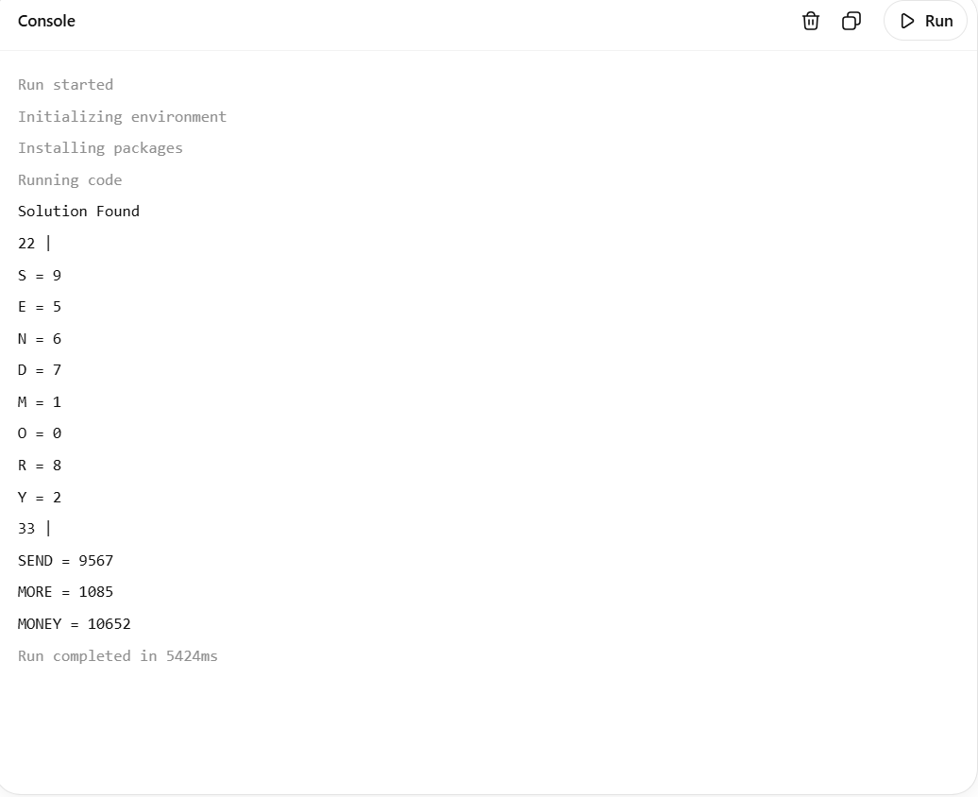

Exp 5
Missionaries and Cannibals Problem

from collections import deque

def is_valid(m_left, c_left):

m_right = 3 - m_left
c_right = 3 - c_left

# Invalid number of people
if m_left < 0 or c_left < 0:
return False

if m_right < 0 or c_right < 0:
return False

# Missionaries cannot be outnumbered
if m_left > 0 and m_left < c_left:
return False

if m_right > 0 and m_right < c_right:
return False

return True

def solve():

# State = (Missionaries left,
# Cannibals left,
# Boat side)

# Boat side: 0 = Left, 1 = Right
start = (3, 3, 0)
goal = (0, 0, 1)

queue = deque()

queue.append((start, [start]))

visited = set()
visited.add(start)

# Possible boat movements
moves = [
(1, 0),
(2, 0),
(0, 1),
(0, 2),
(1, 1)
]

while queue:

state, path = queue.popleft()

m_left = state[0]
c_left = state[1]
boat = state[2]

if state == goal:
return path

for m, c in moves:

if boat == 0:
# Boat moves Left to Right
new_state = (
m_left - m,
c_left - c,
1
)

else:
# Boat moves Right to Left
new_state = (
m_left + m,
c_left + c,
0
)

if is_valid(
new_state[0],
new_state[1]
):

if new_state not in visited:

visited.add(new_state)

queue.append(
(new_state, path + [new_state])
)

return None

solution = solve()

if solution:

print("Missionaries and Cannibals Solution:")
print()

step = 0

for state in solution:

m_left = state[0]
c_left = state[1]
boat = state[2]

m_right = 3 - m_left
c_right = 3 - c_left

if boat == 0:
boat_position = "Left"
else:
boat_position = "Right"

print("Step", step)
print(
"Left -> Missionaries:",
m_left,
"Cannibals:",
c_left
)

print(
"Right -> Missionaries:",
m_right,
"Cannibals:",
c_right
)

print("Boat:", boat_position)
print()

step = step + 1

else:

print("No solution exists.")
Output:
